Eco-Club and PNB join hands for a greener tomorrow.

"N.S.C.B.M. Govt. Degree College, Hamirpur, witnessed the successful organization of a plantation donation drive by the Eco-Club of GC Hamirpur and Punjab National Bank (PNB), New Road Hamirpur on 12th September,2023. PNB demonstrated its commitment to Corporate Social Responsibility (CSR) by generously donating plants for developing Eco-Club Garden. Representatives from PNB, including Mr. Arvind Kumar Saroch (Circle Head Hamirpur), Ayush Bhutani (Chief Manager), Karan Abrol (Manager), Sushil Bhatia (Dy. Manager), and Aman Chopra (Officer), were present to show their support. Dr. Pramod Singh Patial, the College Principal along with Dr. Kalpna Bhandari, the Eco-Club Convener graced the event and praised the efforts of Eco-Club and encouraged the volunteers in enhancing the campus's aesthetics through this noble initiative.
Furthermore, PNB vowed to continue their support and dedication for the activities of Eco-Club in future as well.
PHOTOGRAPHS OF THE EVENT

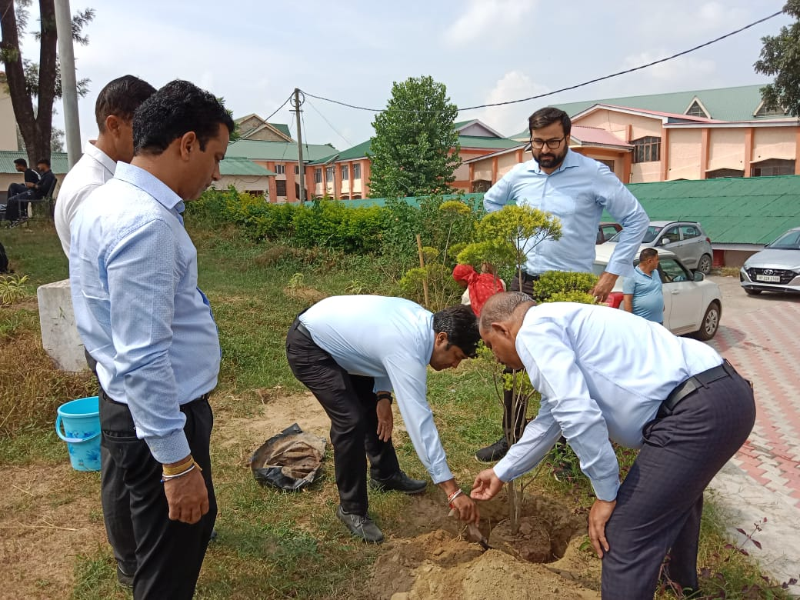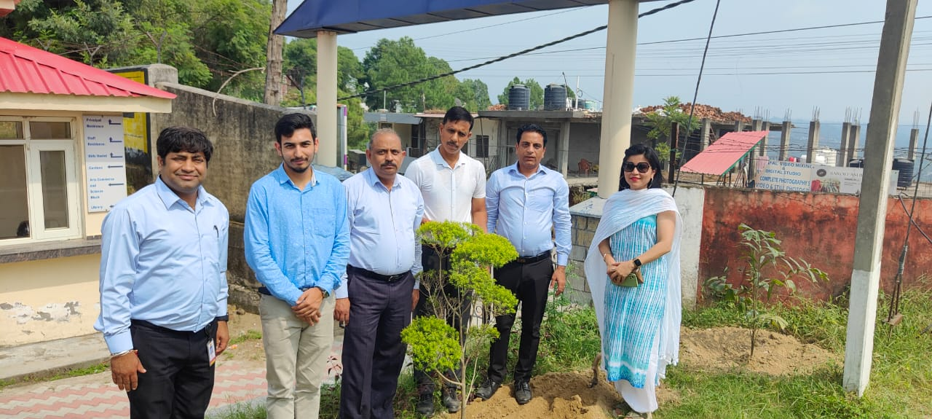

Submitted by;
Dr. Kalpna Bhandari
Convener
Eco-Club

