"Green Initiative: TATA TISCON and Eco-Club Collaborate for Campus Beautification Drive"

The collaboration between the Eco-Club of GC Hamirpur and TATA-TISCON Hamirpur resulted in a successful plantation donation drive on 25th August,2023 at N.S.C.B.M. Govt. Degree College, Hamirpur. TATA-TISCON exemplified its commitment to Corporate Social Responsibility (CSR) by generously donating plants for this initiative. Representatives from TATA, Mr. Praveen Kaundal, Business Manager, and Mr. Neeraj Sharma, Area Sales Officer, were present to symbolize the company's support. Dr. Pramod Singh Patial, the College Principal, honored the occasion by acknowledging and praising the unwavering dedication of Dr. Kalpna Bhandari, the Eco-Club Convener, and the volunteers for their efforts toward enhancing the campus's aesthetics through this noble initiative.

Furthermore, TATA expressed their dedication to continuing their support for the Eco-Club in the future, vowing to uphold their commitment to this cause.

PHOTOGRAPHS OF THE EVENT

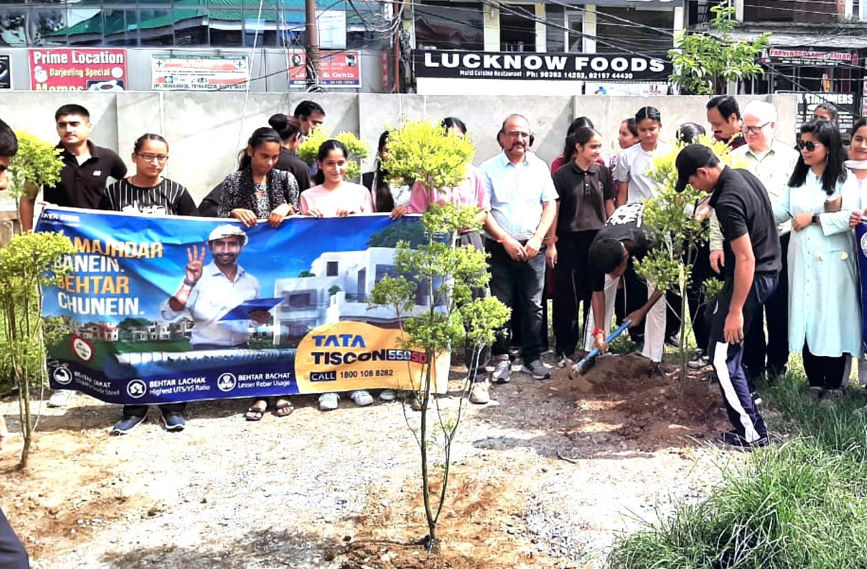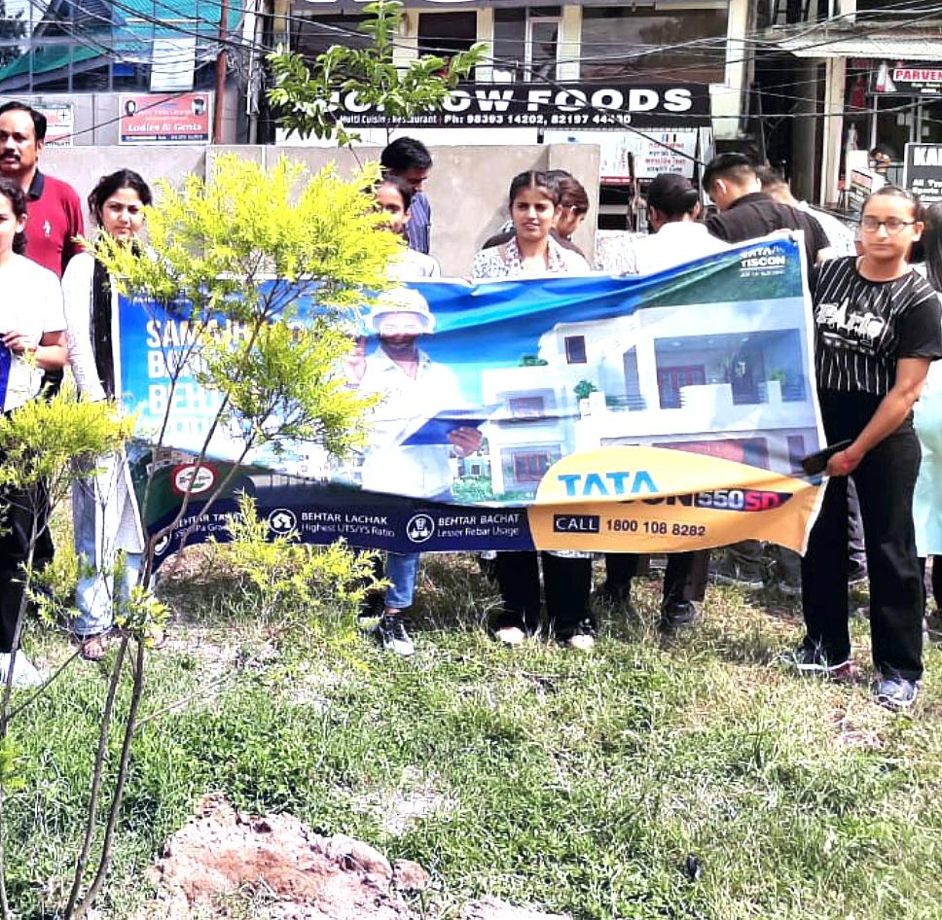

Submitted by;
Dr. Kalpna Bhandari
Convener
Eco-Club

